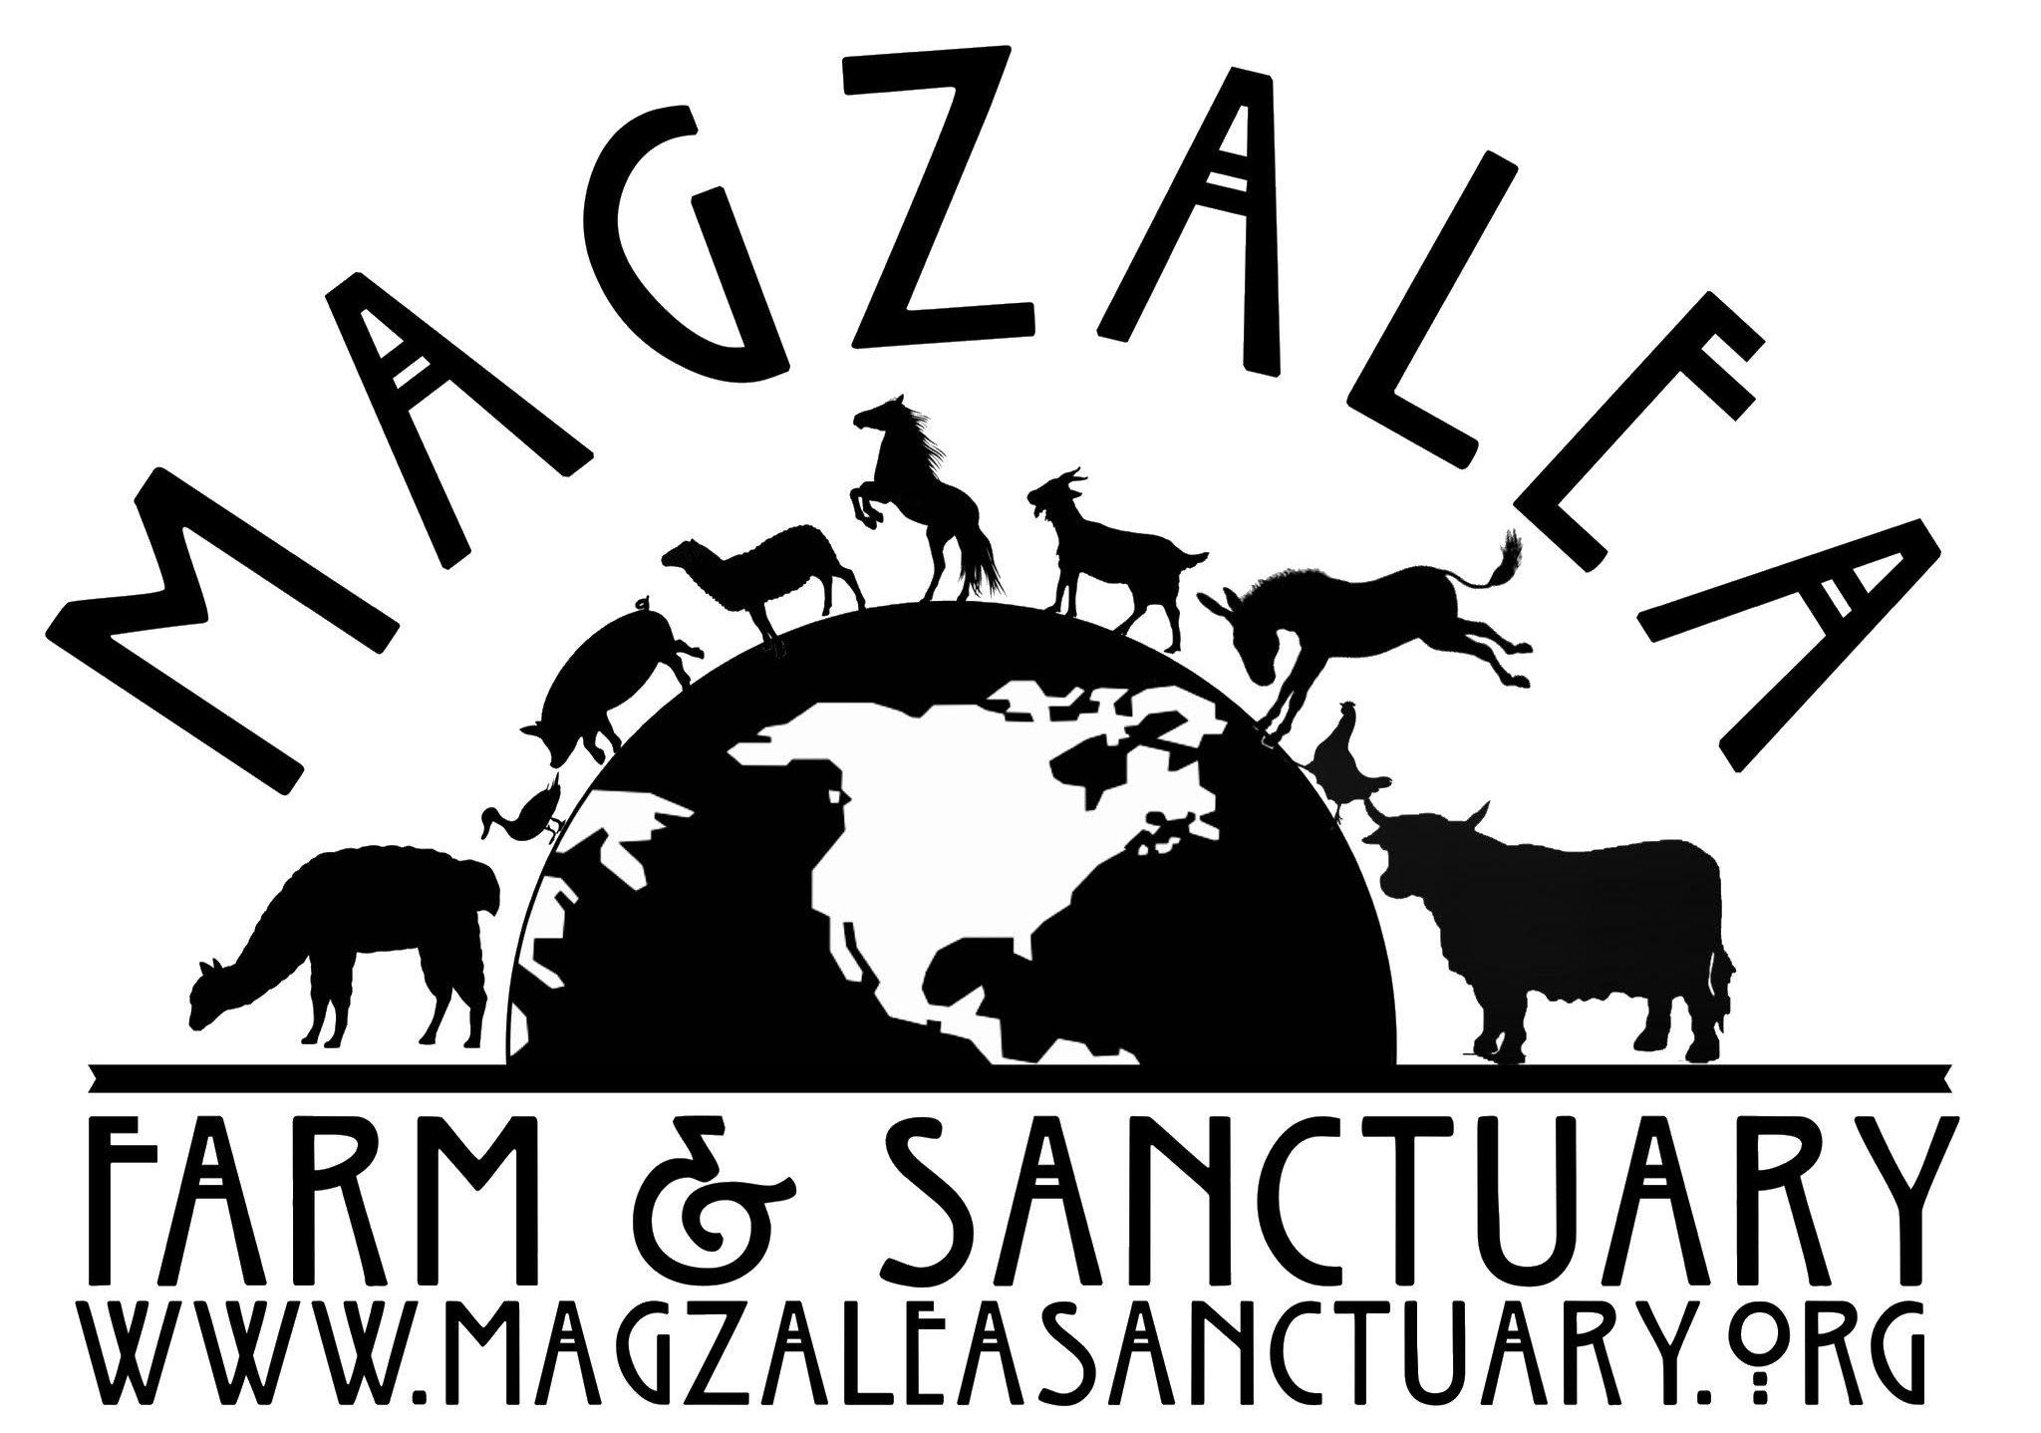
Volunteer Application
First and foremost we want to THANK YOU! Thank you for wanting to donate your time and/or skills to helping the amazing animals that call Magzalea home. Your information will always be confidential and only used as part of the Magzalea Farm & Sanctuary Volunteer Program. We only require this packet to be completed once for our records. Please be patient and understand that every question is important to ensure you have the best experience possible when working with us.
To submit your completed packet: Please mail your completed form to 218 West Lake Rd, Fitzwilliam, NH 03447 OR scan and e-mail to magzalea@gmail.com OR bring hard copy with you to Volunteer Orientation).
PERSONAL INFORMATION (Please print):
Name: _____________________________________________________________________ Date: _____________________________
Address: _______________________________________________________________________________________________________
Home phone: ___________________ Work/Cell phone: ___________________ Email: ______________________________
Date of Birth: _____________________________ Are you at least 18 years or older? ______
Health History: Please describe your current health status, particularly regarding the physical/emotional demands of volunteering at our animal sanctuary. Examples to address: Any allergies, physical limitations, asthma, arthritis, recent surgeries or hospitalizations. These are important to know when scheduling projects and volunteers. We never want anyone uncomfortable or in any pain from helping us.
_________________________________________________________________________________________________________________
_________________________________________________________________________________________________________________
Please check the areas in which are you interested in volunteering:
Grooming/Socializing ____ Cleaning stalls/pens _____ Building/Repairs _____ Fundraising _____
Website Design/Maintenance _____ Collecting/Transporting Produce _____ Landscaping _____
Please tell us about any other ways you would like to help:___________________________________________________
Do you have any previous experience with animals? If so, what type of animals? Please give a brief description of your experience:
_________________________________________________________________________________________________________________
_________________________________________________________________________________________________________________
_________________________________________________________________________________________________________________
Is there any particular type of animal you are most interested in working with or learning about?
_________________________________________________________________________________________________________________
Are there only certain days/ hours you are available to volunteer?
_________________________________________________________________________________________________________________
Any additional comments, learning interests, skill development etc you would like to share with us?
_________________________________________________________________________________________________________________
_________________________________________________________________________________________________________________
I agree to cooperate with any conditions, to abide by any and all rules pertaining to the care of the animals as well as the property. I understand that the information provided above is accurate to the best of my knowledge. I know of no reason why I should not volunteer for Magzalea Farm & Sanctuary.

Signature

_______________________________________________________________ ______________________
(Volunteer or parent/guardian if a minor) Date

Volunteer Waivers & Releases
Please read the following carefully. This form must be signed prior to volunteering.

Volunteer Liability Release
As a volunteer at Magzalea Farm & Sanctuary, I acknowledge the risks and potential for risks of activities working with animals. However, I feel that the benefits are greater than the risk assumed. I hereby, intending to be legally bound, for myself, my heirs and assigns, executors or administrators, waive and release all claims, demands and damages of every kind and nature whatsoever against Magzalea Farm & Sanctuary, its owners, board of directors, volunteers and employees for any and all injuries and or losses, physical or mental, known or unknown that I may sustain while volunteering at Magzalea Farm & Sanctuary.
Signature
________________________________________________________________________ _______________________
(Volunteer or parent/guardian if a minor) Date
Photo Release
By signing below, I hereby consent to and authorize the use and reproduction by Magzalea Farm & Sanctuary, of any and all photographs and any other audio/visual materials taken of me for promotional material, social media, educational activities, exhibitions or for any other use for the benefit of the program.
Signature
________________________________________________________________________ ________________
(Volunteer or parent/guardian if a minor) Date
Background Information
Have you ever been charged with or convicted of a crime? Yes ______ No ________
If yes, please explain:
_________________________________________________________________________________________________________________
_________________________________________________________________________________________________________________
Please provide the names and contact information for two references:
Name ______________________________________________ Phone __________________________
Name ______________________________________________ Phone __________________________
Authorization for Emergency
Name __________________________________________________________________________________________________________
Address _____________________________________________ City ______________________State _______ Zip _____________
Home Phone_________________________ Cell Phone _____________________________ DOB _________________________
In the event of an emergency, contact: Name__________________________________________________________________
Relation __________________________________________________________ Phone______________________________________
OPTIONAL (BUT HELPFUL IN AN EMERGENCY)
Physician’s Name_______________________________ Medical Facility_____________________________________________
Health Insurance Company _______________________________________Policy # ___________________________________
Allergies to Medications _____________________________ Current Medications ___________________________________
In the event emergency medical aid/treatment is required to due illness or injury while volunteering, or while being on the property of the agency, I authorize Magzalea Farm & Sanctuary to:
1. Secure and maintain medical treatment and transportation if needed.
2. Release participant records upon request to the authorized individual or agency involved in the medical emergency treatment.

CONSENT PLAN
This authorization includes x-ray, surgery, hospitalization, medication and any treatment procedure deemed “lifesaving” by a physician. This provision will only be invoked if the person above is unavailable.
Signature
___________________________________________________________________________ ___________________________
(Volunteer or parent/guardian if a minor) Date
NON-CONSENT PLAN
I do not give my consent for emergency medical treatment/aid in the case of illness or injury while volunteering or while being on the property of the agency. In the event emergency treatment/aid is required, I wish the following procedures to take place:
_________________________________________________________________________________________________________________
_________________________________________________________________________________________________________________
Signature
___________________________________________________________________ _________________
(Volunteer or parent/guardian if a minor) Date
Volunteer Information
Dress Suggestions
While volunteering, we request that for your safety, you should wear closed-toe and non-slip shoes. Boots are preferable, waterproof and/or safety toe, but not steel-toed. Please also refrain from wearing jewelry, especially dangling jewelry. Please be aware that your clothing and shoes may become damaged and or dirty while volunteering (This is very likely).
Injury & Illness
Working with animals may be dangerous and lead to serious injury, illness, or even death. As a volunteer, you understand and agree to personally assume any and all of the liability and risk associated with volunteering for Magzalea Farm & Sanctuary. Further, each volunteer agrees to hold harmless Magzalea Farm & Sanctuary, its owners, directors, officers, agents, employees and other volunteers from any responsibility or liability for any and all illness, injuries, or death which may occur as direct or proximate result of their involvement with Magzalea Farm & Sanctuary.
Tetanus Shot
All volunteers should be current on their tetanus shot. Alternatively, the volunteer acknowledges that failure to acquire and remain current on a Tetanus vaccination may put the volunteer at risk and hereby agrees to hold harmless Magzalea Farm & Sanctuary, its owners, directors, officers, agents, employees and volunteers from any responsibility or liability for any and all illness, injuries, or death as a result.
Signature
____________________________________________________________________ _________________________
(Volunteer or parent/guardian if a minor) Date

