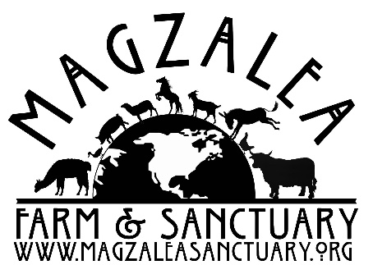
Surrender Questionnaire
Please complete a separate form for each animal if multiple animals are being brought to the sanctuary.

Animal’s name:_______________________________________ Date:_________________

Please circle: Goat Sheep Pig Alpaca Llama Cow Donkey
Rabbit Chicken Duck Turkey Other_______________
Please circle: Female Male
Spayed or Neutered: Y N

Age: ______________ Date of Birth (If known): _________________________________

Reason for surrender:

Vaccinations given: _____________________________________________________________
Date:
Last fecal check (date):__________________Results:_________________________________
Last worming (date):____________________Product used:___________________________
Last hoof trim (date):________________
Veterinarian:_____________________________________________________________________
Veterinary history:
___________________________________________________________________________________

_______________________________________________________________________________________________

While filling out this form please keep in mind that ALL info is important to us, no detail is too small!
How long have you owned this animal? _________________________________________
Please share any information you have about this animal before it came to you.

Where has this animal been housed? Please circle all that apply.
Stall Run in Paddock Barn Other -If Other please explain:
__________________________________________________________________________________

Please be as specific as possible when listing the following:
Your animal is currently being fed:______________________________________________
Amounts:________________________________________________________________________
Time(s) of day:__________________________________________________________________
Required Meds or Supplements: _________________________________________________
Any Health issues we should be aware of or on the look out for:_________________
___________________________________________________________________________________
Please tell us about any parts of his or her body that they do not like having touched:
___________________________________________________________________________________
___________________________________________________________________________________
Please list any “quirks”. Good or not so good. This will help in accommodating their emotional and physical needs, as well as helping in the success of transitioning and acclimated to their new home.
___________________________________________________________________________________
___________________________________________________________________________________
___________________________________________________________________________________
___________________________________________________________________________________

We do not require a surrender fee but if you are able to make a donation toward the care of your animal we would be most grateful.

If we need to transport we do ask for a $25 donation within 25 miles. $50 for 25-50 miles. Further transports can be discussed if needed.

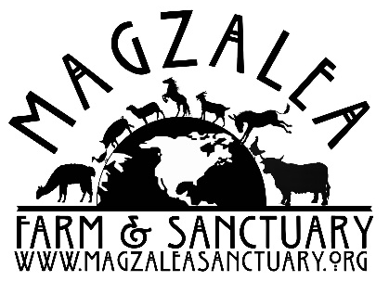
Surrender Release Form

Owner’s name:_________________________________________________________________________________

Address:_______________________________________________________________________________________

Phone number:___________________________ Mobile if different: _____________________________

Email address:__________________________________________

To Magzalea Farm & Sanctuary: I certify that I own the animal described and I hereby surrender all rights, title and interest to Magzalea Farm & Sanctuary. It is expressly agreed that said organization, it’s officers and employees, will incur no obligation to me on account of the disposition of this animal. To the best of my knowledge this animal has not bitten anyone in the past 14 days.
Additionally, I certify that I understand Magzalea Farm & Sanctuary’s euthanasia policy. I understand that my animal may be humanely euthanized by a licensed veterinarian if found to be unsafe by being aggressive or has tried to harm any Magzalea Farm & Sanctuary officer or volunteer. I also understand that my animal may be euthanized for life threatening illness or disease that jeopardizes the rescue organization’s animal population or succumbs to psychological distress.
I hereby certify that I understand and agree to the above conditions.

Signature:________________________________________________Date:__________________

